AP Psychology 12 Name:
Bryant-Taneda Date:
(adapted from WWarren) Block:

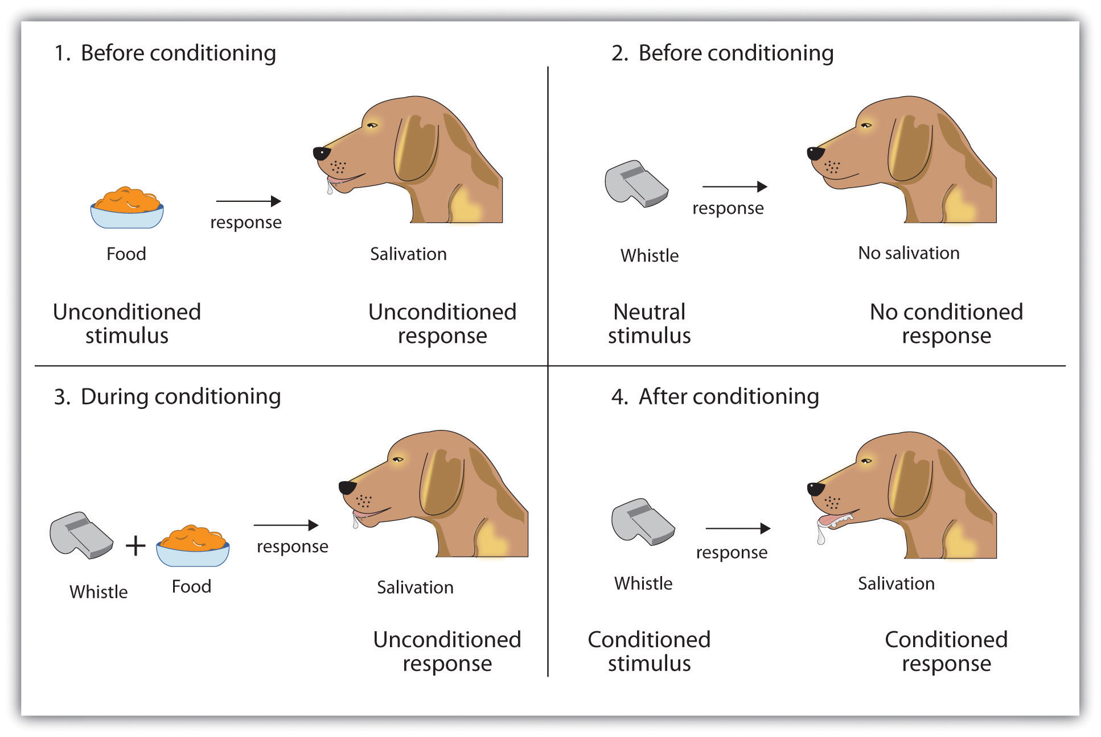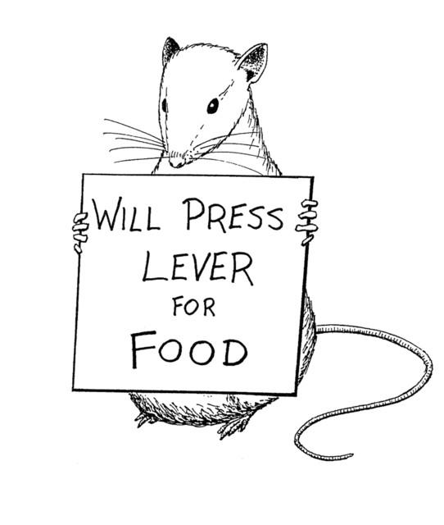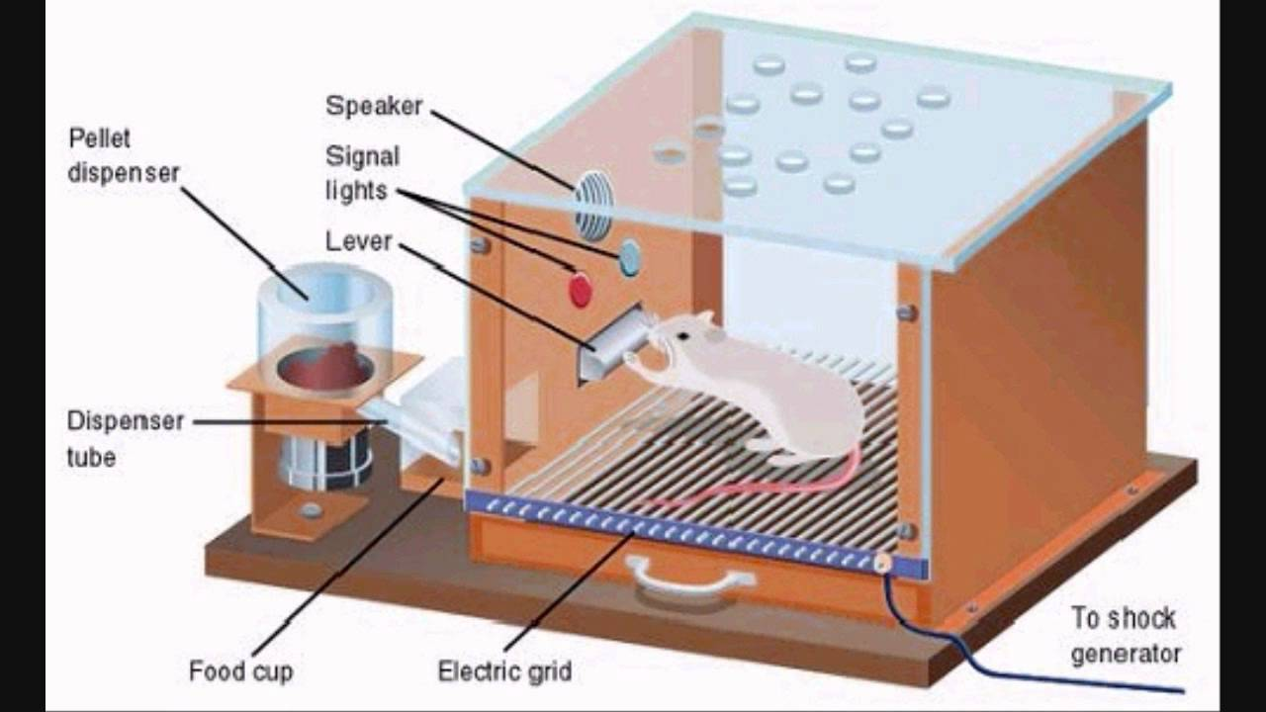
Classical Conditioning Operant Conditioning Skinner box Social Learning Theory

Chapter 8 – Behaviouristic Learning FR Essay /7

AP Psychology Free Response Essay
Dr E. Vil has come up with a diabolical scheme. He wants to prove that cloning is not worth the effort. He plans to prove once and for all that NURTURE is more important than NATURE. He is going to raise baby Minnie-me in a glass cage or air crib away from all environmental influences other than his own.
Dr. E. Vil is going to use three types of Behaviorism to train Minnie-me to do his dirty work. He wants Minnie-me to become a thief and to steal all the human cloning equipment from a Genetics research lab. He needs Minnie-me to steal the equipment at night and to make a quick getaway.
I.
a. Classical Conditioning: Describe a reflexive response he might train in Minnie-me by using Classical Conditioning.
b. Operant Conditioning: Explain what behaviour will be taught. Explain how will it be done using a Stimulus and Response Procedure. Describe how Dr E. Vil might train the voluntary response using Operant Conditioning.
c. Shaping: What behaviour will he train Minnie-me to adopt? How will Dr. E. Vil Shape this behaviour?
d. Modeling: What role will Modeling play?
II.
Explain how this will work. Defend your answer using information learned from any psychology chapter:
a. Ivan Pavlov: Classical Conditioning research
b. B.F. Skinner: Operant Conditioning research
c. Albert Bandura: Observational Learning research

Criteria
- Remember to use the AP Psych FR Essay format: Term – Definition – Application of the definition to the question
- Write your answer to the question in the order of the FR essay question
- Highlight or underline psychological question terms/researchers’ names
- Attach your rough work

Comments:

